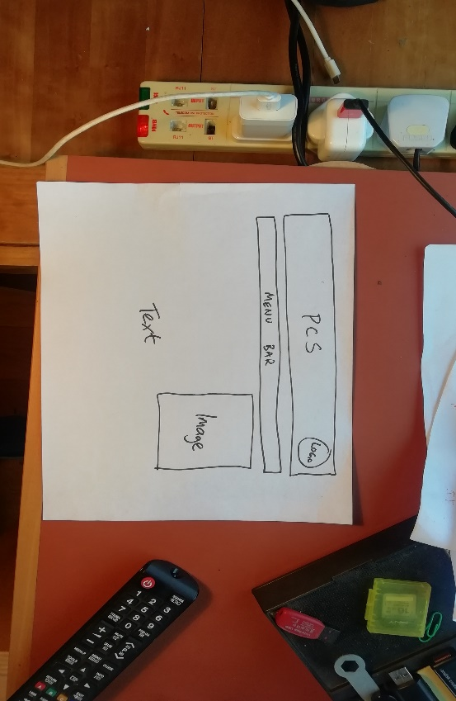

|  |  |  |  |
| --- | --- | --- | --- |
| **C** | **Example** | | |
| **Question**  Below is a visualisation diagram for a new website for PCS. Discuss the suitability of the diagram. [12] | | **Answer**  One strength4 of the visualisation diagram is that it clearly shows the web designer1 the layout3 of the title and menu bar4. This will help her know how to arrange the web page2,9.  One weakness5 is the font7 is not specified, so the web designer1 will not know which font to use9. To improve6 this, annotations7 could be included. | |
| 1Target Audience  2Purpose  3Content  4Strength  5Weakness | 6Areas for improvement  7Technical vocab  8Specific  9Explanation |

|  |  |  |  |
| --- | --- | --- | --- |
| **A** | | **Evaluating Pre-Production Documents** | |
| **1** | **Target Audience** | | Don’t get confused between the target audience of the document and the target audience of the product |
| **2** | **Purpose** | | When you are explaining a strength, weakness or improvement you must show you understand the purpose of the document |
| **3** | **Content** | | You must know what is normally in this type of document |
| **4** | **Strengths** | | It may be very bad, but it will still have strengths. Make sure you mention them and explain them |
| **5** | **Weaknesses** | | Weaknesses are not the same as areas for improvement. Address them separately and explain them both |
| **6** | **Areas for improvement** | |
| **7** | **Technical vocabulary** | | Use a lot of the key vocab words on these organisers. |
| **8** | **Be specific** | | Show a detailed understanding of the scenario you are discussing |
| **9** | **Explain each point** | | Explanations should always refer to the target audience and the purpose of the pre-production document |

|  |  |  |
| --- | --- | --- |
| **B** | **Key Vocab** | |
| **Discuss** | | Evaluate, and give reasons for each of the points you are making. Write several paragraphs |
| **Suitability** | | How well something does its job |
| **Target audience of the document** | | The pre-production document will normally be aimed at a member of a production team – camera crew, client, script writer etc – not the general public |
| **Target audience of the product** | | The product will be aimed at a certain demographic of the general public |

Name:

R081: Evaluation of Pre-production Documents